Day 1 - 16th May 2025

Your Doc name: SDLC

Eid - 109883998

Name-Rishabh Manchanda  
  
What is SDLC?

Software Development Life Cycle, is basically the step-by-step journey of building software. It starts with understanding what users need, then planning, designing, coding, testing, and finally launching the software. Even after it's live, updates and fixes are part of the cycle.It helps to deliver the product to the end customer with less costing and bugs,We need to follow the correct path of SDLC.  
  
  
  
  
Task 2:

Why is SDLC ?  
  
The Software Development Life Cycle (SDLC) is used to ensure a structured and efficient process for developing software. It helps in planning, designing, building, testing, and maintaining software systematically. By following SDLC, teams can reduce errors, avoid project delays, and control costs. It improves collaboration and leads to the delivery of high quality software to the end user.

Task 3:  
What are the stages of SDLC?  
  
Requirement Gathering- We have to understand what the client or end users actually want.

Planning- We have to plan once the requirements are clear, team plans out the resources,tools, and cost.

Design- Then team architects and designers create the blueprint using UI/UX designs, database structure, and system architecture.

Development- Now here comes the main part, developers build the software based on the designs and planned features and code accordingly.

Testing- After development, testers check the software for bugs ,issues and make sure it works as expected. This includes functional, performance, and security testing.

Deployment- Once testing is successful, the software is launched to final users.

Maintenance- After the deployment the work is not finished, we need to updates, bug fixes, and support this phase continues as long as the software is in use.  
  
Task 4:

SDLC Models:

Waterfall Model- Its has a linear and sequential or in a sequence approach where each phase requirement, design, implementation, testing, deployment, maintenance is completed before the next begins. It is best for well defined, unchanging requirements and documentation heavy and big projects.

Task 5:

Applications of SDLC -

We can apply when requirements are fixed, and well documented. Steps to be followed Requirements ,Design ,Implementation ,Testing ,Deployment ,Maintenance. It is suitable for government or documentation heavy software projects.

Eg- Building a house

Task 6:

**Advantages** -

1. It is easy to manage due to clear structure.
2. It is good for well-defined, unchanging requirements.

**Disadvantages**-

1. It is difficult to go back to previous stages.
2. It has poor adaptability to changes mid-project.

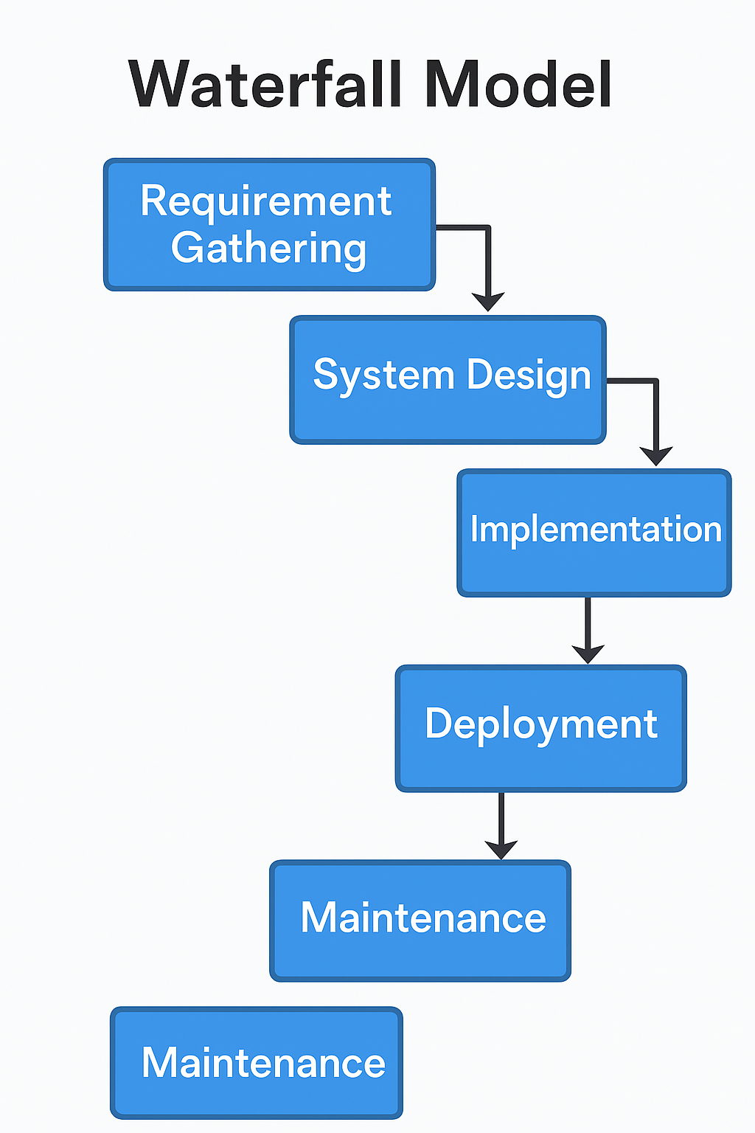

### V-Model (Verification and Validation)

An extension of the Waterfall model, where each development phase is directly associated with a testing phase. Focuses on validation and verification early in the life cycle. Emphasizes quality and reliability.

We can apply for safety critical systems like medical or aerospace. Follow: Requirement Analysis ,Acceptance Testing, System Design -System Testing, Architectural Design -Integration Testing, Module Design Testing.

Example: Car manufacturing

**Advantages-**

1. The testing is planned early and parallel to development.
2. It ensures high-quality output.

**Disadvantages-**

1. It is very rigid and not flexible to changes.
2. It is Not suitable for ongoing or long-term projects.

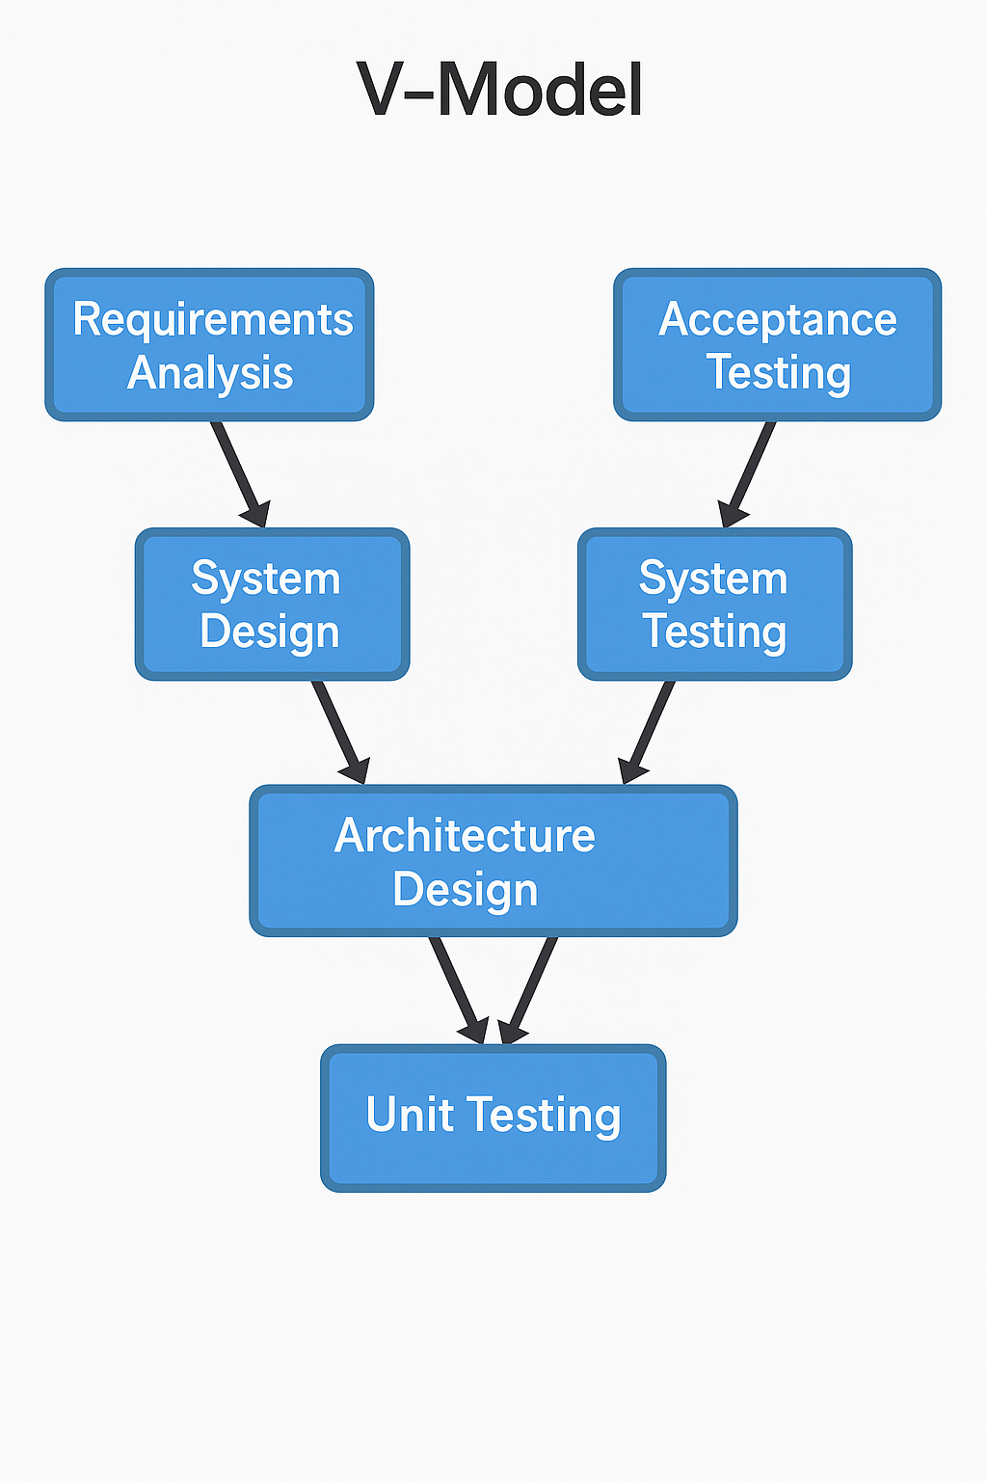

Iterative Model

The Software is developed and improved through repeated cycles (iterations). Each version adds features based on feedback. Ideal for evolving requirements and early product delivery with continuous refinement.

We can use it when requirements evolve. Steps: Plan initial requirements Design,Implement basic version ,Test ,Get feedback ,Improve next version ,Repeat until final system is stable.

Example: Writing a new code

**Advantages-**

1. Early version of product is available quickly
2. Easy to adapt to changing requirements

**Disadvantages-**

1. It requires more resources and time.
2. It has a lot of risk if not controlled properly.

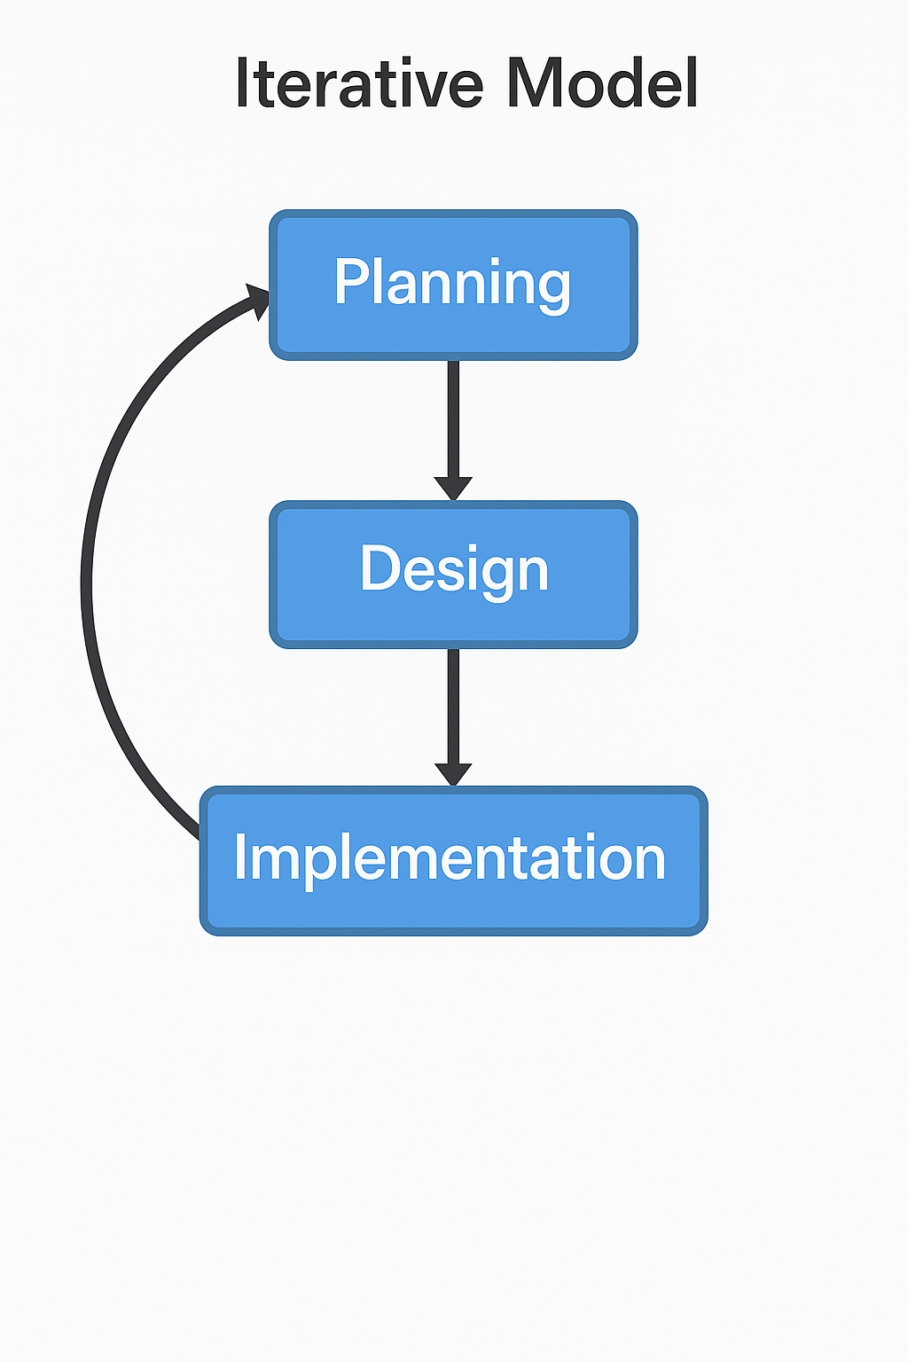

### Agile Model

An adaptive, iterative model with collaborative teams delivering small working software increments quickly.It Focuses on flexibility, customer feedback ,satisfaction and continuous improvement. Commonly uses Scrum, Kanban.

Ideal for dynamic environments. Steps: Plan sprint ,Gather requirements ,Design ,Develop ,Test ,Review with client,Retrospect ,Repeat. Great for startups and SaaS Software as a Service

Example: Mobile app development

**Advantages-**

1. It is highly flexible and adaptive to change.
2. It is Continuous user involvement and satisfaction.

**Disadvantages-**

1. It requires an experienced team and constant collaboration.
2. It is difficult to predict time and cost in early stages.

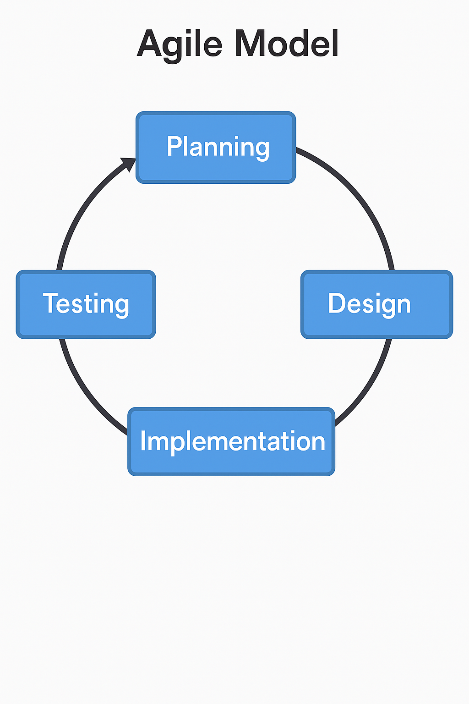

### Spiral Model

It combines iterative development with risk analysis. Each loop or spiral includes planning, risk assessment, development, and evaluation. Suitable for large, complex, and high-risk projects requiring frequent reassessment.

It is used for large, risky, complex systems. Steps: Identify objectives ,Assess risks ,Develop prototype ,Test ,Evaluate with stakeholders ,Plan next phase. Repeat in spiral cycles. Ideal for banking, defense.

**Advantages-**

1. Great for large, high-risk projects.
2. Risks are identified and handled early.

**Disadvantages**-

1. Expensive and time-consuming.
2. Complex to manage and execute.

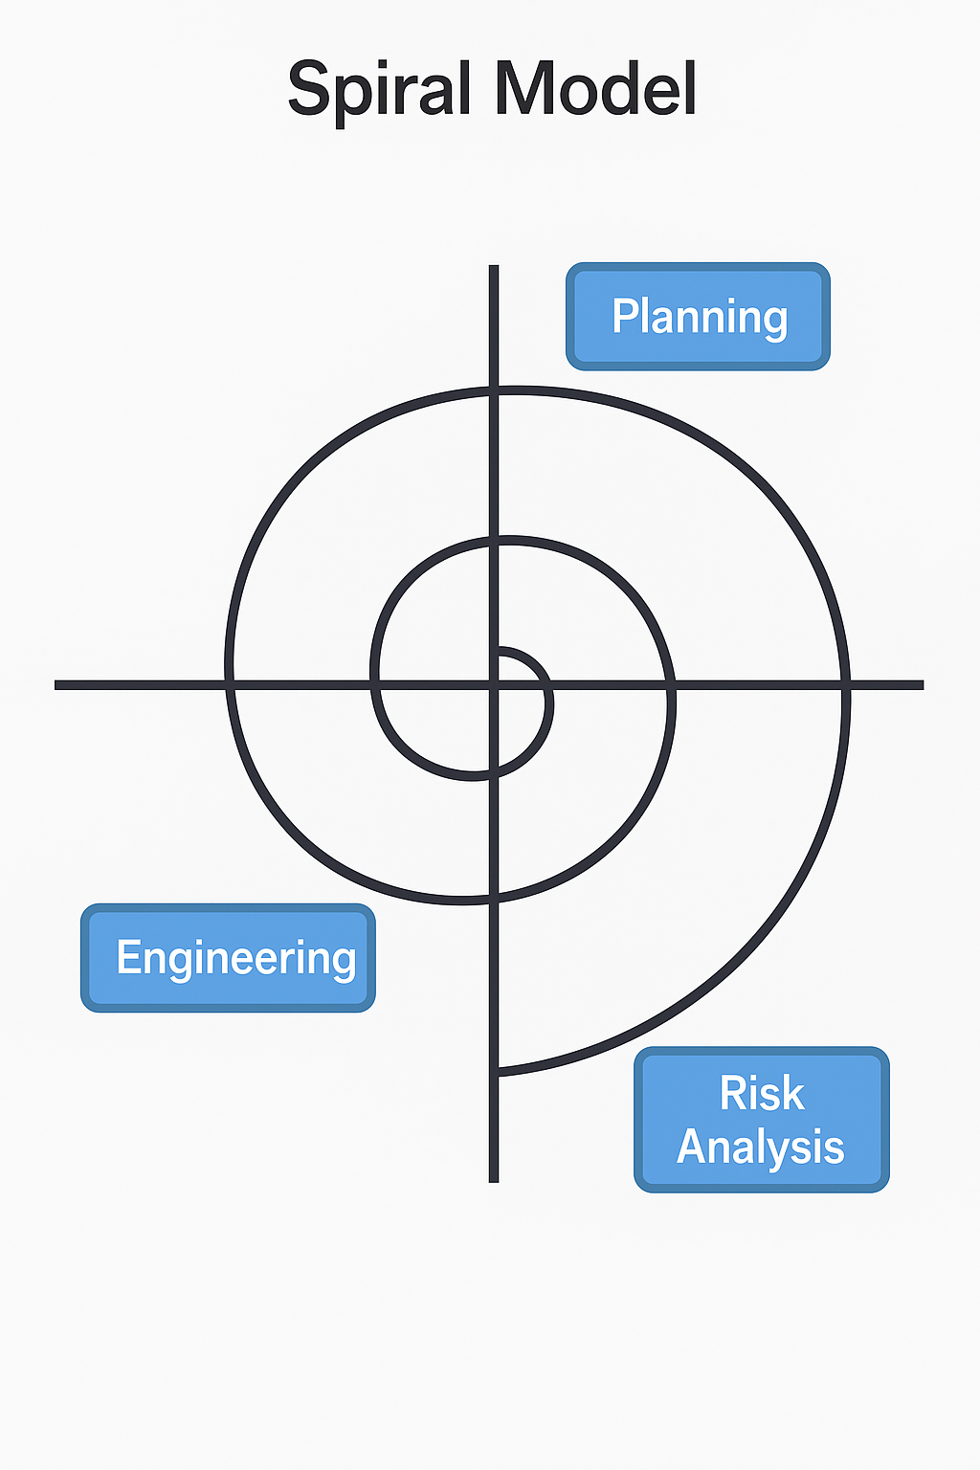

Example: Designing a space mission

Task 7:

**What is Scrum?**

Scrum is a way for teams to work together, especially in project management and software development. It promotes teamwork, accountability, and continuous improvement, with roles like Product Owner, Scrum Master etc

It improves transparency, adapts to changing requirements, ensures frequent delivery, and enhances team collaboration.

Scrum in Agile is a lightweight, iterative framework used to manage and deliver complex projects efficiently. It breaks work into small, manageable units called sprints allowing teams to deliver functional product increments frequently.

The Scrum master is accountable for helping team members and interact, collaborate and maximize the delivered value.

Task 8:

**What is Sprint** ?

In layman language, sprint is a daily stand ups for to do list and a fixed-length timebox, typically 2-4 weeks, during which a cross-functional team works to complete a specific amount of work and deliver a potentially shippable increment of the product.

Task 9:  
  
**What needs to be followed in the sprint and what not ?**

* **To be followed**

**Sprint Goal is Clear:** Every sprint must have a specific, agreed-upon objective.

**Fixed Timeframe:** Sprint duration is fixed (usually 1–4 weeks) and must not change once started.

**No Scope Change Mid-Sprint:** Requirements locked during the sprint no new tasks should be added.

* **To not be followed**

**Don’t Change Sprint Scope Midway** Adding new tasks or requirements mid-sprint breaks focus and flow.

**Don’t Allow Unclear User Stories** Tasks must be well-defined before they enter the sprint backlog.

**Don’t Assign Tasks Without Team Input** Scrum is collaborative; no one should force tasks on team members.

Task 10:

**What are stories and backlogs?**

A story is a brief description of a feature from the user’s perspective. It defines what they want, why it's needed, and it guides development with clarity.

In layman terms a backlog is a prioritized list of tasks, features, or requirements that the team needs to work on. It evolves continuously and guides what gets built in each sprint.

Task 11:

**Scrum artifacts-**

### **1. Product Backlog**

* A prioritized list of everything the product needs features, enhancements, bug fixes, etc.
* Managed by the Product Owner
* Continuously refined and updated

### **2. Sprint Backlog**

* Selected tasks for the current sprint.
* Includes:  
  + Sprint Goal
  + Selected user stories
  + Tasks to complete them
* Owned by the Development Team
* Updated daily during stand-ups

### **3. Increment**

* The working product after each sprint.
* Should be potentially shippable and usable
* Combines all completed backlog items from the sprint

Task 12

**What are ports and protocols in networking?**A port is a virtual point where network connections start and end. Each service on a device listens on a specific port number.

For example IP address or building address ,Port or specific room number

Networking protocols use port numbers that are based on the type of packet being sent or received. A network host typically runs many software packages, so when it receives a packet it looks to the port number to identify which process should get it.

Protocols are sets of rules that define how data is formatted, transmitted, and received across a network.They ensure that data is exchanged reliably and correctly between devices.

Task 13:

**What are different types of networks?**

### **LAN (Local Area Network):**

LAN is used to connect computers and devices in a small area like a home, school, or office. It helps share files, printers, and the internet easily. It’s fast, cheap, and perfect for a limited geographical area. Office WIFI or home WIFI.

### **MAN (Metropolitan Area Network):**

A MAN links several LANs across a city or large campus. It’s bigger than a LAN but smaller than a WAN. For example, a city’s college campuses can be connected using a MAN for better data sharing.

### **WAN (Wide Area Network):**

WAN covers large areas, even countries or continents. The internet is the biggest example. It connects multiple LANs and MANs, often using satellites, cables, or fiber optics. It’s essential for global communication but can be slower and costlier.

### **WLAN (Wireless Local Area Network):**

WLAN is basically Wi-Fi. It connects devices like phones and laptops to the internet without wires. You use it daily at home, cafes, or offices. It's a wireless version of LAN, offering flexibility and mobility in small areas.

### **PAN (Personal Area Network):**

A PAN connects your personal devices within a short range, like your phone, smartwatch, or wireless headphones. It’s mainly used via Bluetooth or USB. Think of it as your gadget's personal space for communication, fast and direct.

Task 14:

**What are the types of servers ? Make a list and write 2 to 3 liners about it.**

Servers come in various types, each specializing in different tasks within a network. Here's a list of common server types:

* **Web Servers:**These servers host websites and web applications, delivering web pages to users through their browsers. They manage requests and responses for web content.
* **Mail Servers:**Mail servers handle the sending, receiving, and storage of email messages. They use protocols like SMTP (Simple Mail Transfer Protocol)for outgoing and POP3/IMAP for incoming emails.
* **Database Servers:**These servers manage and store data within databases. They provide efficient data access and retrieval for various applications.
* **Application Servers:**Application servers provide a platform for running and hosting web applications, including web services and APIs.
* **Network Servers:**These servers manage and facilitate communication and resource sharing among networked devices, offering services like file sharing, print services, and directory management.
* **Print Servers:**Print servers manage the printing process for networked printers, allowing users to print from their computers without directly connecting to the printer.
* **Proxy Servers:**Proxy servers act as intermediaries between clients and other servers. They can cache web pages, improve security, and control access to the internet.
* **Virtual Servers:**Virtual servers are created within a single physical server. They provide a virtual environment for running multiple operating systems or applications.
* **DNS Servers:**DNS servers translate domain names into IP addresses, allowing users to access websites using memorable names.
* **Backup Servers:**Backup servers are responsible for creating and storing backups of data, ensuring data recovery in case of failures or disasters.

Task 15:

**What do you know about DNS? Domain Name system.**

DNS is the system that translates website names into IP addresses allowing users to access websites easily by typing names instead of numbers making internet navigation simple and efficient.

It is like the phonebook of the internet.It converts human readable domain names (like www.google.com) into **IP addresses** (like 142.250.190.78) that computers use to communicate with each other.DNS acts as a directory for the internet, converting domain names into IP addresses.   
  
**What is a VPN?**

VPN (Virtual Private Network) creates a secure and private connection over a public network like the internet.  
 It hides your IP address, encrypts your data, and lets you access content securely and anonymously like a private tunnel to the internet.

Task 16:

**What are different type of topology ?**

Network topology refers to the layout or structure of how computers, devices, and cables are connected in a network. It defines how data flows and how devices interact.  
  
**Types of Network Topologies:**

1. Bus Topology- All devices share a single communication line where data travels in both directions.Easy to set up and cost effective.

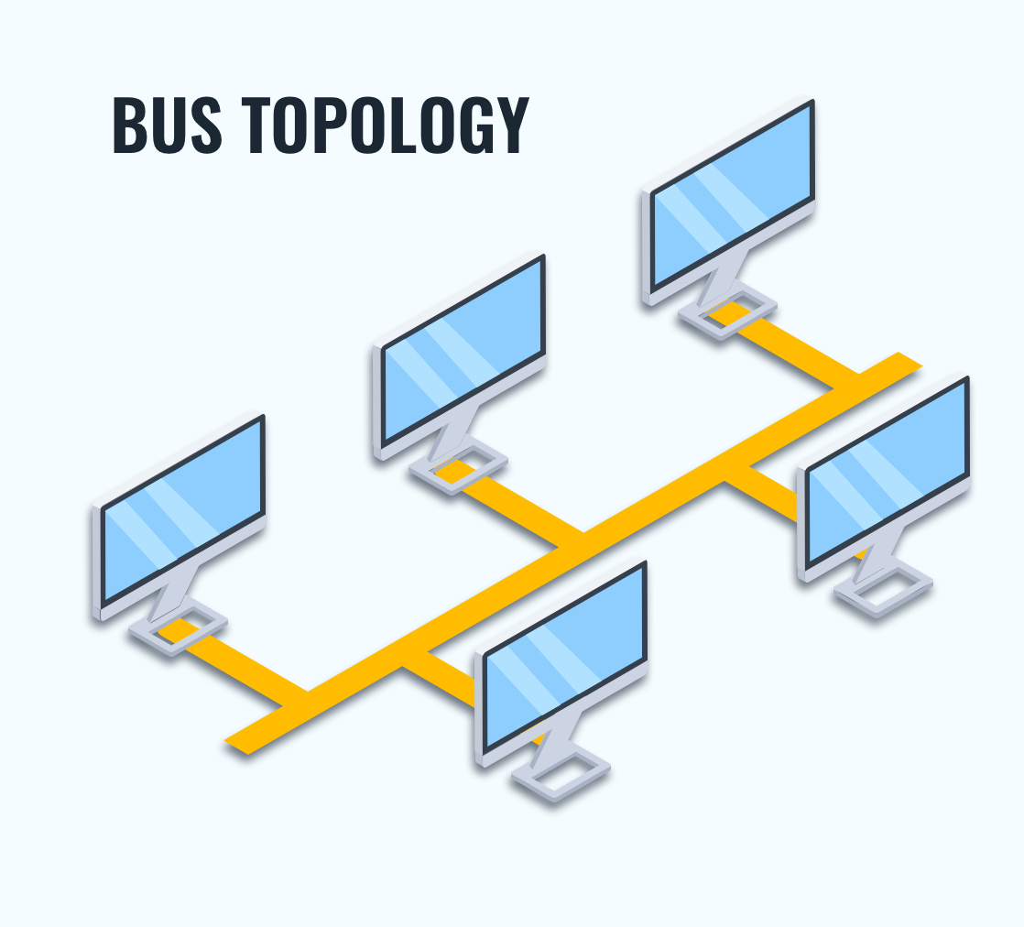

1. Star Topology- All devices are connected to a central hub or switch, which manages data transmission. It is easy to manage and expand, failure of node does not affect other but hub failure brings down the entire network.

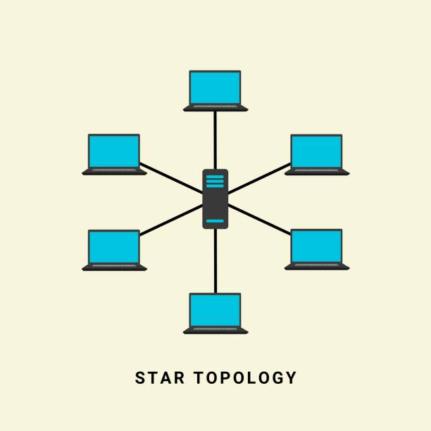

1. Ring Topology-Devices are connected in a circular fashion where data travels in one direction.Data flows in one direction reducing collision.  
   Failure of network can affect the whole network.

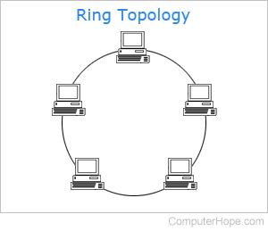

1. Tree Topology-A combination of star and bus topologies with hierarchical structure of connected nodes . It is easy to manage in large networks.

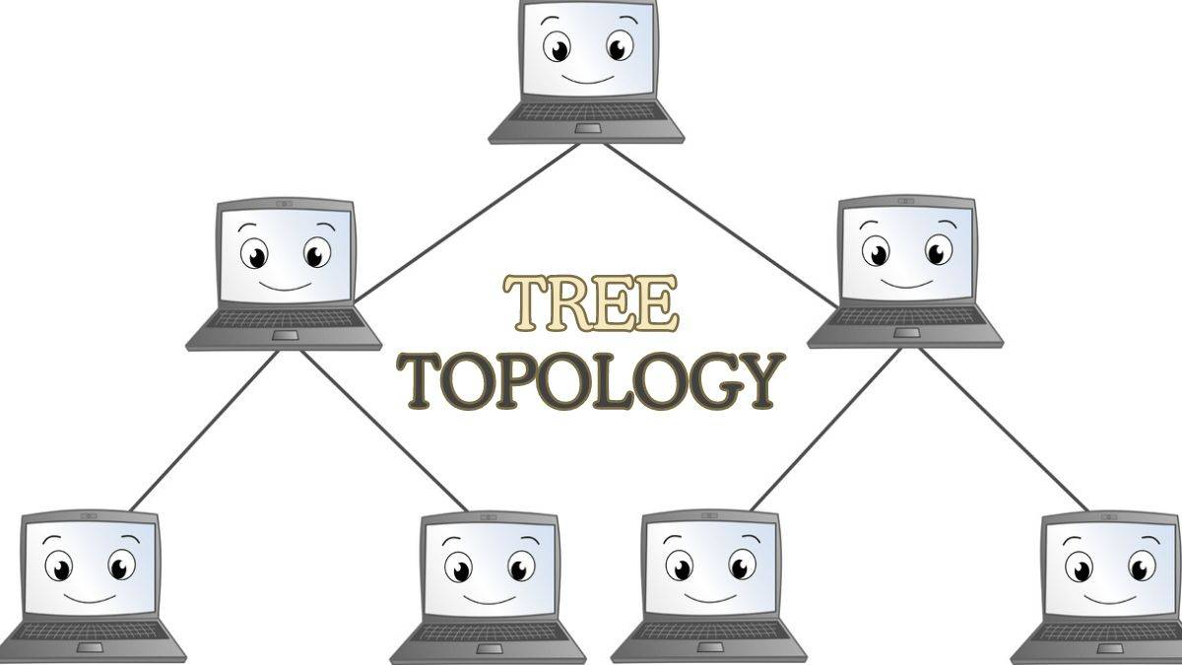

5. Mesh Topology – Every device is connected to every other device, providing high redundancy and reliability. It is very expensive and it requires complex setup and maintenance.

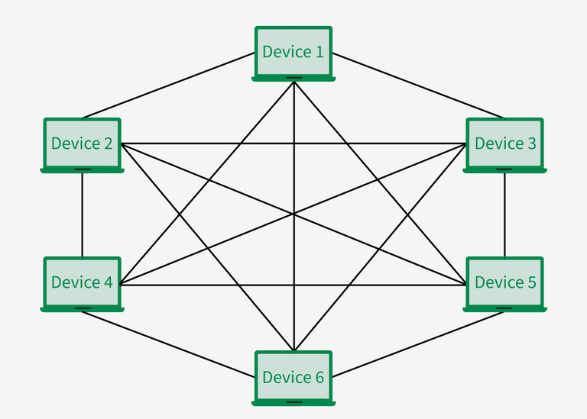

**What is OSI Model ?Describe the 7 layers with description.**The OSI Model (Open Systems Interconnection Model) is a conceptual framework that standardizes how data is transmitted over a network in seven layers. Each layer has a specific role in moving data from one device to another.  
  
1. Physical layer-Deals with physical connection cables, switches, voltages. Transmits raw bits.

2.Data Link Layer-Handles error detection, MAC addressing, and node-to-node communication.

3.Network Layer-Responsible for routing and IP addressing. Directs data between networks.

4.Transport Layer-Ensures complete and reliable data delivery (TCP/UDP-User Datagram Protocol). Manages flow control.

5.Session Layer-Manages sessions or connections between apps (e.g., opening/closing connections).

6. Presentation Layer- Translates, encrypts, or compresses data (e.g., JPG, MP4, SSL).

7. Application Layer- Closest to the user deals with applications like browsers, email, etc.